NTPC-SAIL POWER COMPANY (PVT.) LIMITED

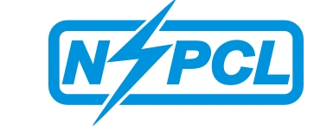

(A JOINT VENTURE OF NTPC & SAIL)
NOTICE INVITING TENDER (NIT)
(DOMESTIC COMPETITIVE BIDDING)
CORRIGENDUM (for extension of different dates). Date 26.09.2016
NIT.NO.NSPCL/ROURKELA/16-17/03
Sl.No | Tender No | Works Description of Tender | Date of closing of sale of tender extended to | Date of last date of query extended to . | Date of opening of Technical bid extended to .
01 | 1614061 | BMC for maintenance of Milling System and Rotary Equipments. | 06.10.2016 | 06.10.2016 | 07.10.2016
All other terms and condition of above tender will remain same as per original NIT.
NIT.NO.NSPCL/ROURKELA/16-17/04
Sl.No | Tender No | Works Description of Tender | Date of start of sale of tender extended to | Date of closing of sale of tender extended to | Date of last date of query | Date of opening of Technical bid
01 | 1609063 | Manufacturing of Fly ash Brick of standard Size by using Cement at NSPCL, Rourkela | 30.09.2016 | 21.10.2016 | 28.10.2016 | 08.11.2016
This tender will be on sale off line. Interested bidders will have to apply offline to C&M , NSPCL, Rourkela. Rest of the terms and condition will remain same as that of original NIT.
All other terms and condition of above tender will remain same as per original NIT

